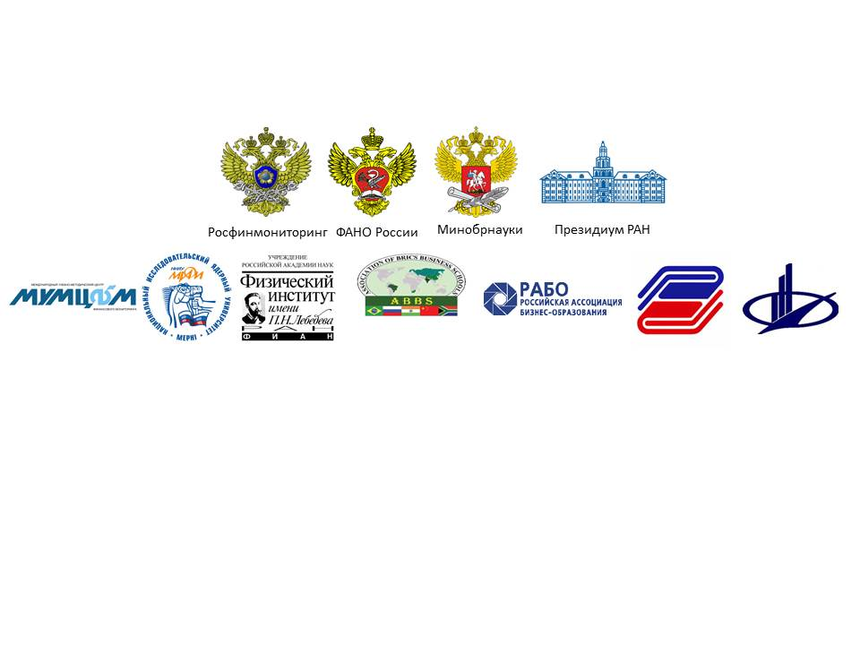

**AGENDA**

**III**

**III Network AML/CFT Institute International Scientific and Research Conference**

**“FinTech and RegTech: Possibilities, Threats and Risks of Financial Technologies”**

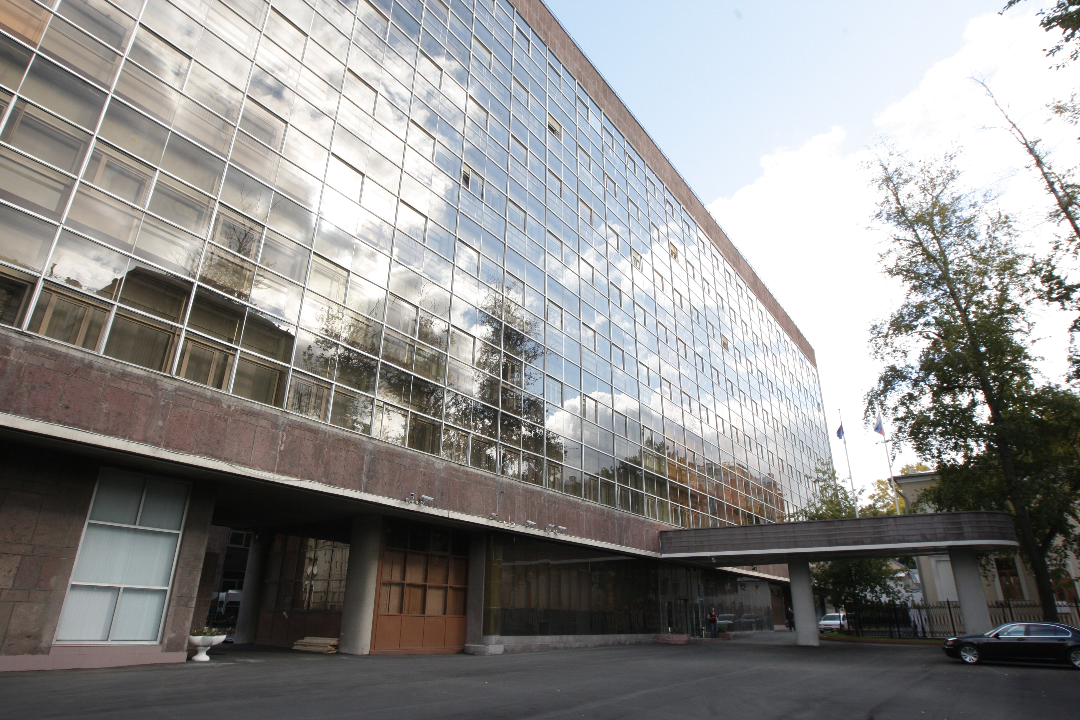

**Russian Federation, Moscow**

**November 21-23, 2017**

*Dear participants of the Forum*

***“FinTech and RegTech: Possibilities, Threats and Risks of Financial Technologies”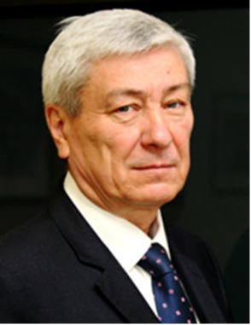****,*

*On behalf of the Federal Financial Monitoring Service,*

*I welcome you in the Russian capital!*

*Current global trends are directly connected with the revolutionary technologies in the financial sector, including payment systems, asset management, credit, insurance and foreign exchange transactions.*

*New challenges and threats emerge. They have a supranational character and may not be tied to specific jurisdictions, therefore they are not fully regulated by the national legislation. Such phenomena can include growing popularity of cryptocurrency, crowdfunding technology (inter alia, via non-traditional means of payment), use of biometric technology during identification procedures for the execution of payment transactions.*

*During the last revision of the Financial Action Task Force (FATF) standards, the special focus was on assessing risks of money laundering or terrorist financing that could arise due to the development of new products and business practices, including the use of modern technology.*

*One of international, regional and national AML/CFT systems’ priorities in terms of prospects for the introduction of new financial technology (FinTech) is the creation of a platform for constructive dialogue and support of innovation in financial services, and finding solutions for their regulation and control.*

*FinTech innovations can improve financial inclusion of customers, entities and communities. The financial services paradigm can be reorganized around new platforms, infrastructures and relations with service providers. The prospect of the international AML/CFT community’s efforts is to understand how these changes will affect the landscape of financial services, stability of the financial system, opportunities to identify, eliminate or reduce risks and threats.*

*In the modern world financial threats and risks became quite a systemic thing. Therefore, they can be dealt with only by systemic methods. Scientific and educational organizations play an important role in this fight. Joint efforts of financial monitoring bodies, academic community and network AML/CFT Institute will contribute to strengthening and development of the system of international and regional financial security.*

*Yours sincerely,*

*Yury Chikhanchin*

*Rosfinmonitoring Director*

**Conference Program Committee**

**Committee Chairman** – **Yury Chikhanchin**, Director of the Federal Financial Monitoring Service, Chairman of the network AML/CFT Institute Council

**Committee Co-Chairs:**

1. **Olga Vasilyeva,** Minister of Education and Science of the Russian Federation
2. **Mikhail Kotyukov**, Head of the Federal Agency for Scientific Organizations of the Russian Federation
3. **Alexander Sergeyev,** President of the Russian Academy of Sciences

**Members of the Conference Program Committee:**

1. **Sergey Ablameyko,** Rector of the Belarus State University, member of the network AML/CFT Institute Council
2. **Chinara Adamkulova,** Rector of the Kyrgyz National University named after Jusup Balasagyn, member of the network AML/CFT Institute Council
3. **Adam Albekov**, Rector of the Rostov State University of Economics, member of the network AML/CFT Institute Council
4. **Bahodir Begalov,** Rector of the Tashkent Financial Institute, member of the network AML/CFT Institute Council
5. **Chingiz Bekenov,** Director of the Training and Methodology Centre at the State Financial Intelligence Agency under the government of the Kyrgyz Republic, member of the network AML/CFT Institute Council
6. **Mahmujon Boltabayev,** Rector of the TashkentStateEconomic University, member of the network AML/CFT Institute Council
7. **Yevgeny Vaganov,** Rector of the Siberian Federal University, member of the network AML/CFT Institute Council
8. **Erkin Gadoyev,** Rector of the Tax Academy at the State Tax Committee of the Republic of Uzbekistan, member of the network AML/CFT Institute Council
9. **Viktor Grishin,** Rector of the Plekhanov Russian University of Economics, member of the network AML/CFT Institute Council
10. **Fyodor Voytolovsky,** Deputy Director of the Institute of World Economy and International Relations of the Russian Academy of Sciences, RAS Academician
11. **Alexey Zabelin**, Rector of the Moscow University of Finance and Law, member of the network AML/CFT Institute Council
12. **Sergei Ivanchenko**, Rector of the Pacific National University, member of the network AML/CFT Institute Council
13. **Yesemurat Kamyazov,** Rector of the Tashkent State University of Law, member of the network AML/CFT Institute Council
14. **Victor Koksharov,** Rector of the Ural Federal University named after the first President of Russia B. N. Yeltsin, member of the network AML/CFT Institute Council
15. **Natalya Korjova,** President of the Financial Academy under the Ministry of Finance of the Republic of Kazakhstan, member of the network AML/CFT Institute Council
16. **Nikolai Kolachevsky,** Director of P.N.Lebedev Federal State Budgetary Scientific Institution of the Russian Academy of Sciences, RAS Academician
17. **Yerkin Kubeev**, Rector of the E. A. Buketov Karaganda State University, member of the network AML/CFT Institute Council
18. **Kambar Kudrat,** Rector of Financial and Economic Institute of Tajikistan, member of the network AML/CFT Institute Council
19. **Oleg Kuznetsov**, President of the Russian Academy of Natural Sciences, member of the network AML/CFT Institute Council
20. **Ivan Lobanov,** Rector of the State University of Management, member of the network AML/CFT Institute Council
21. **Valery Makarov**, Director of the Central Economics and Mathematics Institute of the Russian Academy of Sciences, academician of the Russian Academy of Sciences
22. **Almaz Nasyrov**, Rector of the Public Administration Academy under the President of the Kyrgyz Republic, member of the network AML/CFT Institute Council
23. **Vladimir Nechaev,** Acting Rector of the Sevastopol State University, member of the network AML/CFT Institute Council
24. **Vladimir Nifadyev**, Rector of the Kyrgyz-Russian Slavic University named after the first President of the Russian Federation B. N. Yeltsin, member of the network AML/CFT Institute Council
25. **Alexander Novikov**, Rector of the Novosibirsk State University of Economics and Management, member of the network AML/CFT Institute Council
26. **Gennady Osipov**, Director of the Institute of Social and Political Studies of the Russian Academy of Sciences, academician of the Russian Academy of Sciences
27. **Andrey Rudskoy**, Rector of Peter the Great St. Petersburg Polytechnic University, corresponding member of the Russian Academy of Sciences, member of the network AML/CFT Institute Council
28. **Nurali Salikhov,** Rector of theRussian-Tajik (Slavonic) University,member of the network AML/CFT Institute Council
29. **Tulkin Teshabaev,** Rector of the Tashkent University of Information Technology, member of the network AML/CFT Institute Council
30. **Andrey Falaleev,** Acting Rector of the Vernadsky Crimean Federal University, member of the network AML/CFT Institute Council
31. **Taliya Khabrieva**, Director of the Institute of Legislation and Comparative Law under the Government of the Russian Federation, Vice-President of the Russian Academy of Sciences, academician of the Russian Academy of Sciences, member of the network AML/CFT Institute Council
32. **Chitilencheri Ravindranathan**, honorary professor and Council member of the Xavier Institute of Management and Entrepreneurship (XIME), member of the Association of BRICS Business Schools Council, Bangalore, India(to be confirmed)
33. **Yevgeny Chuprunov**, Rector of the Lobachevsky State University of Nizhny Novgorod, member of the network AML/CFT Institute Council
34. **Shimov Vladimir,** Rector of the Belarus State Economic University, member of the network AML/CFT Institute Council
35. **Mikhail Eskindarov**, Rector of the Financial University under the Government of the Russian Federation, member of the network AML/CFT Institute Council

**Conference Steering Committee**

**Chairman of the Steering Committee** – **Vladimir Glotov**, Deputy Director of the Federal Financial Monitoring Services, Director of the Institute of Financial and Economic Security at the National Research Nuclear University (NRNU MEPhI), Deputy Chairman of the network AML/CFT Institute Council

**Co-chairs of the Steering Committee:**

1. **Pavel Zenkovich,** State Secretary, Deputy Minister of Education and Science– Co-Chair of the IWG
2. **Nikolai Kolachevsky,** Director of P.N.Lebedev Federal State Budgetary Scientific Institution of the Russian Academy of Sciences, RAS Academician
3. **Ivan Lobanov,** Rector of the State University of Management, member of the network AML/CFT Institute Council
4. **Yevgeny Bazhanov**, Rector of the Diplomatic Academy of Russian Foreign Ministry, member of the network AML/CFT Institute Council
5. **Mikhail Strikhanov,** Rector of the National Research Nuclear University (MEPhI), Deputy Chairman of the network AML/CFT Institute Council
6. **Alexey Zabelin**, Rector of the Moscow University of Finance and Law, member of the network AML/CFT Institute Council

**Members of the Steering Committee:**

1. **Vladimir Godin,** Head ofInformation Systems Department, State University of Management, Professor, PhD in Economics
2. **Vladimir Ovchinnikov**, Deputy General Director, International Training and Methodology Centre for Financial Monitoring (ITMCFM) , Director of the network AML/CFT Institute
3. **Oleg Ivanov,** Deputy Development Director,P.N. Lebedev Federal State Budgetary Scientific Institution of the Russian Academy of Sciences
4. **Andrey Leonidov,** Head of Mathematical Complex Systems Modeling Laboratory, Department of Theoretical Physics, P.N. Lebedev Federal State Budgetary Scientific Institution of the Russian Academy of Sciences, PhD in Physics and Mathematics
5. **Anna Norkina**, Deputy Director of the Institute of Financial and Economic Security, NRNU MEPhI, PhD in Economics
6. **Tatyana Zakuratseva,** First Vice Rector of the Diplomatic Academy of Russian Foreign Ministry, Deputy Chair
7. **Oleg Ivanov**, General Director of the International Training and Methodology Center for Financial Monitoring (ITMCFM)
8. **Ekaterina Butkeeva**, Deputy Head of Education and Science Department, ITMCFM, PhD in Pedagogical science
9. **Irina Ivanova**, Advisor to the Director, Federal Financial Monitoring Service
10. **Elena Bochkareva**, Director, Institute of Additional Education, Moscow University of Finance and Law, PhD in Economics
11. **Pavel Kukushkin**, Deputy Head of International Department , ITMCFM
12. **Shamil Magomedov,** Head of the AML/CFT Laboratory, Market Economy Institute of the Russian Academy of Sciences, Professor, PhD in Economics
13. **Alexey Petrenko**, Head of the International Cooperation Department, Federal Financial Monitoring Service
14. **Giorgy Ramishvili**, Head of International Department, ITMCFM
15. **Nina Smirnova,** Deputy Head of International Department, ITMCFM
16. **Irina Shilina**, Head of Education and Science Department, ITMCFM

**Conference Participants**

1. Federal Financial Monitoring Service (Headquarters and Interregional Departments)
2. Federal Agency for Scientific Organizations of the Russian Federation
3. Russian Academy of Sciences
4. Russian Association of Business Education
5. Eurasian Group on Combating Money Laundering and Financing of Terrorism (EAG) Secretariat
6. Commonwealth of Independent States (CIS) Executive Committee
7. Public Administration Academy under the President of the Kyrgyz Republic (Kyrgyzstan)
8. Belarus State University (Belarus)
9. Belarus State Economic University (Belarus)
10. Higher School of Economics (Russia)
11. State University of Management (Russia)
12. Diplomatic Academy of Russian Foreign Ministry (Russia)
13. Institute of Legislation and Comparative Law under the Government of the Russian Federation (Russia)
14. Primakov National Research Institute of World Economy and International Relations (Russia)
15. Institute of Social and Political Studies of the Russian Academy of Sciences (Russia)
16. Institute of Security and Information Analysis (Russia)
17. E. A. Buketov Karaganda State University (Kazakhstan)
18. China Centre for Anti-money Laundering Studies, Fudan University, Shanghai (China)
19. Vernadsky Crimean Federal University (Russia)
20. Kyrgyz National University named after Jusup Balasagyn (Kyrgyzstan)
21. Kyrgyz-Russian Slavic University named after the first President of Russia B N. Yeltsin (Kyrgyzstan)
22. International Training and Methodology Center for Financial Monitoring (ITMCFM) (Russia)
23. Moscow University of Finance and Law (Russia)
24. Tax Academy at the State Tax Committee of the Republic of Uzbekistan (Uzbekistan)
25. National Research Nuclear University MEPhI (Russia)
26. Lobachevsky State University of Nizhny Novgorod (Russia)
27. Novosibirsk State University of Economics and Management "NSUEM" (Russia)
28. Beijing University, International Research Centre on Anti-Money Laundering, Terrorism Financing and Tax Evasion, Faculty of Law (China)
29. Beijing Foreign Studies University (China)
30. Rostov State University of Economics (RSUE) (Russia)
31. Russian Academy of Natural Sciences (Russia)
32. Plekhanov Russian University of Economics (Russia)
33. Russian-Tajik (Slavonic) University (Tajikistan)
34. Peter the Great St. Petersburg Polytechnic University (Russia)
35. Sevastopol State University (Russia)
36. Siberian Federal University (Russia)
37. Tashkent State Economic University (Uzbekistan)
38. Tashkent State University of Law (Uzbekistan)
39. Tashkent University of Information Technology (Uzbekistan)
40. Tashkent Financial Institute (Uzbekistan)
41. Pacific National University (Russia)
42. Ural Federal University named after the first President of Russia B N. Yeltsin (Russia)
43. Training and Methodology Centre at the State Financial Intelligence Agency under the government of the Kyrgyz Republic (Kyrgyzstan)
44. Financial University under the Government of the Russian Federation (Russia)
45. Financial and Economic Institute of Tajikistan (Tajikistan)
46. Central Economic Mathematical Institute of the Russian Academy of Sciences (Russia)
47. Jilin University of Finance and Economics (China)
48. Karunya University (India)
49. P.N. Lebedev Physical Institute of the Russian Academy of Sciences (Russia)

**Day 1: Tuesday, November 21, 2017**